python -m venv .venv 🡪 1st step to create virtual environment

.venv\Scripts\activate 🡪 2nd step to activate the virtual env.

deactivate 🡪 to deactivate the virtual environment

pip freeze 🡪 to check what packages are installed in virtual env.

pip freeze > requirements.txt 🡪 it will create a **requirement.txt** file containing the names of required packages of that project’s virtual environment and that can be shared to others as well

pip install -r requirements.txt 🡪 all packages mentioned in **requirement.txt** file would be installed in the virtual environment

cls 🡪 to clear screen

cd <folder name> 🡪 To change the folder in Terminal

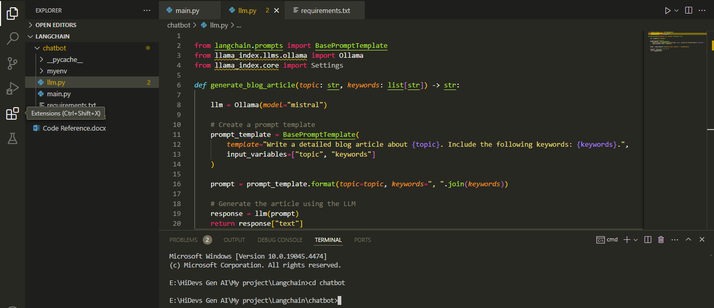

cd.. 🡪 To move back to previous folder

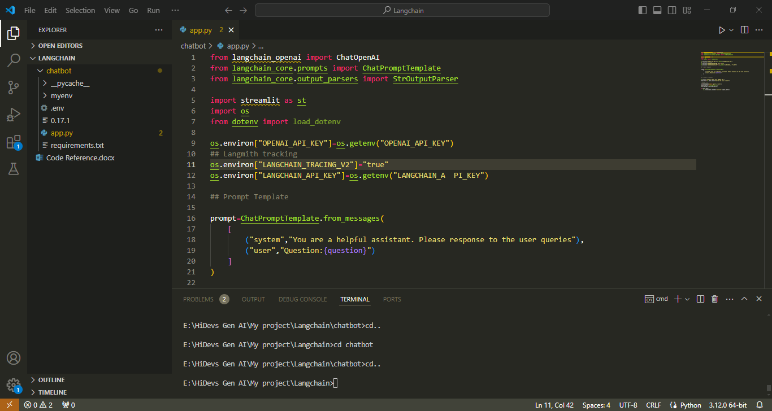

1. pip install uvicorn
2. pip install 'uvicorn[standard]'
3. uvicorn main:app

When Uvicorn Server runs successfully

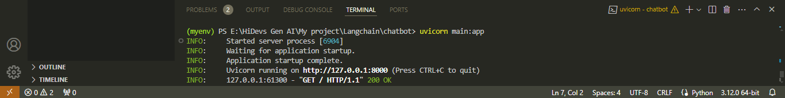

Press **Cntrl C** to shut down the application

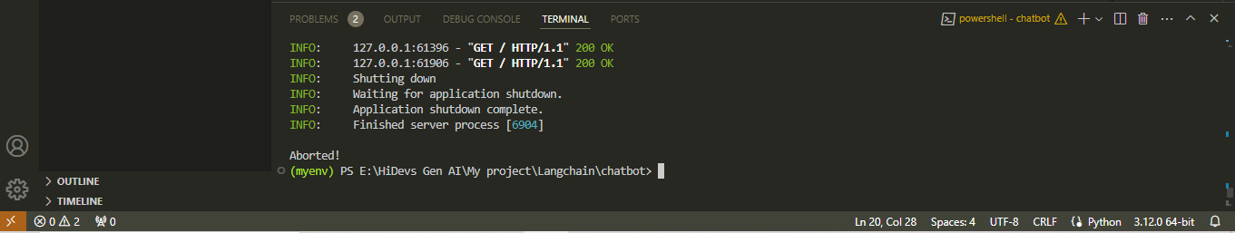

To reload the project in VS Code

View 🡪 Command Pallete 🡪 Developer: Reload Window

Use pip install <Package Name> --user while installing anything shows error in 1st attempt

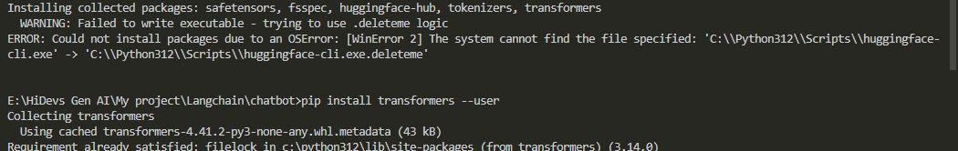

pip install -U langchain-community

Environment Variable:

pip install python-dotenv

python.exe -m pip install --upgrade pip 🡪 To upgrade pip

**Conda Environment**

conda create -p myenv python=3.10 -y

conda activate myenv/